Instructions to the Authors
Christopher de Souza Lima Francisco & Karina Perez Mokarzel Carneiro
Instituto Nacional de Telecomunicações – Inatel
christopher@inatel.br, karina@inatel.br

Abstract—This document contains information on the preparation of the final version of a paper accepted for publication in the Congresso de Iniciação Científica do Inatel, INCITEL. Please carefully follow the instructions provided to ensure legibility and uniformity of accepted papers.
Index Terms—About four keywords or phrases in alphabetical order, separated by commas.

I. INTRODUCTION
The purpose of this document is to provide information to assist authors in producing professional papers for the Inatel Scientific Initiation Congress, INCITEL.

II. GENERAL INSTRUCTIONS
When writing your article, please pay attention to the following instructions:

A. Paper Size and Format
Printed papers on letter-size sheets will appear exactly as you submit them. Therefore, organization and attention to detail are of utmost importance. Please carefully proofread grammatical and typing errors before submission. The article must be between 4 and 6 pages in length. We rely on the authors’ good judgment in this regard.
The articles should be prepared in a double-column format. Set the top and bottom margins to 1.78 cm, and the left and right margins to 1.65 cm. The columns should be 8.89 cm wide, and the space between them should be 0.51 cm. Use single spacing between the lines.

B. Sections and Subsections
Sections must be numbered with Roman numerals and have centered titles. Subsections must be numbered with uppercase letters and have justified titles. If there are subsequent subtitles, the letters should be lowercase and justified.
b.1) Sub-subsection
Example of a sub-subsection.

C. Figures and Tables
Figures and Tables should be included as part of the text whenever possible; otherwise, group them at the end of the text. Figures must not contain colored elements, and their captions should be placed below them, centered. They must be numbered using Arabic numerals. For Tables, the procedure differs: captions should be placed above the tables, centered, and numbered using Roman numerals. Figures should be referenced in the text as follows: Figure 1 shows the INCITEL logo.



Fig. 1. An example figure. The caption should be placed below it.

D. Equations
Equations should be numbered within parentheses and aligned to the right, as shown in the example below:
ϕ_{X}(s) = E[e^{sx}] (1)
For more mathematical symbols, consult the LaTeX wiki [1].

E. Fonts
Use Times New Roman or a similar font. The sizes to be used are shown in Table I.

TABLE I
TAMANHOS E TIPOS DE LETRAS
TEXT | SIZE | STYLE
Title | 24pt | Bold
Author Name | 11pt | Normal
Affiliation | 10pt | Normal
Main text | 10pt | Normal
Section titles | 10pt | Uppercase
Subsection titles | 10pt | Italic
Abstract title | 9pt | Bold,Italic
Abstract text | 9pt | Bold
Figure captions | 8pt | Normal
Table captions | 8pt | Uppercase
Table text | 8pt | Normal
References | 8pt | Normal

F. References
List the references in numerical order at the end of the paper. At the end of this document, several examples are provided to illustrate how to list them according to their type. Cite references in the text using square brackets (for example, [2]). When referencing more than one work, use the same pair of brackets, as in [2, 3, 4].
Here is an example of a textual citation: “According to Lima et al. [2].”

G. Other Issues
Do not use footnotes unless they are strictly necessary; in such cases, avoid grouping them.

III. CONCLUSION
Do not duplicate the abstract as a conclusion. The conclusion should discuss the significance of the work or suggest applications and extensions.

IV. ACKNOWLEDGMENTS
This section is optional. In it, you may acknowledge individuals and/or organizations that supported or facilitated the development of your work.

REFERENCES
- WikiBooks. LaTeX/Mathematics. URL: en.wikibooks.org/ wiki/LaTeX/Mathematics (visited on 07/01/2019).
- P. Lima, E. Guerra, P. Meirelles, L. Kanashiro, H. Silva, and F. Silveira. “A Metrics Suite for Code Annotation Assessment”. In: Journal of Systems and Software 137 (2018), pp. 163–183. ISSN: 0164-1212. DOI: https: / / doi . org / 10 . 1016 / j . jss . 2017 . 11 . 024. URL: http : / / www . sciencedirect . com / science / article / pii / S016412121730273X.
- J. Schell. The Art of Game Design: A Book of Lenses. 2nd. A. K. Peters, Ltd., 2014. ISBN: 1466598646, 9781466598645.
- P. Lima, E. Guerra, M. Nardes, A. Mocci, G. Bavota, and M. Lanza. “An Annotation-based API for Supporting Runtime Code Annotation Reading”. In: Proceedings of the 2Nd ACM SIGPLAN International Workshop on MetaProgramming Techniques and Reflection. Meta 2017. Vancouver, BC, Canada: ACM, 2017, pp. 6–14. ISBN: 978-1-4503-5523-0. DOI: 10 . 1145 / 3141517 . 3141856. URL: http://doi.acm.org/10.1145/3141517.3141856.

AUTORES
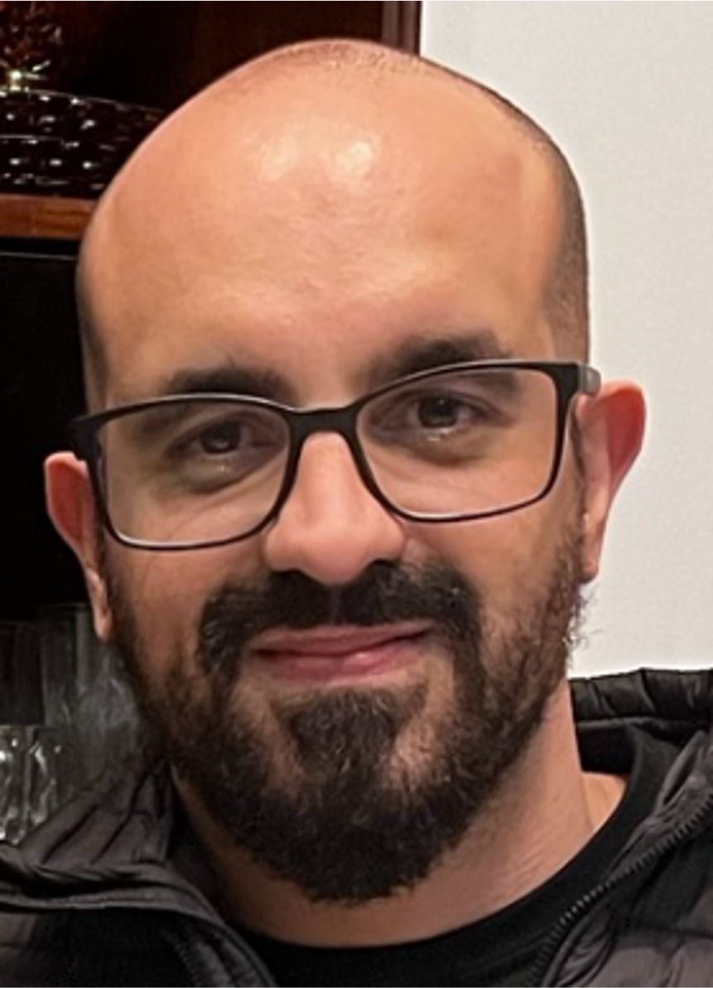
Christopher de Souza Lima Francisco He holds a master’s degree in computer science and technology from the Federal University of Itajubá (UNIFEI) and a Bachelor’s degree in Computer Engineering from the National Institute of Telecommunications (Inatel). He is currently a Professor in the undergraduate program at Inatel, teaching courses such as Software Quality Engineering, Software Engineering, Software Product Engineering, and DevOps. He has previously worked as a Systems Specialist at Inatel in the areas of software quality and continuous integration systems. His experience and research interests lie primarily in Software Engineering and Software Quality.

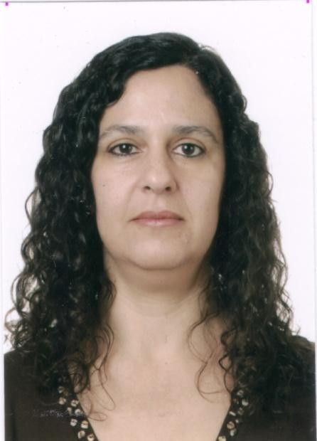
Karina Perez Mokarzel Carneiro holds a bachelor’s degree in electrical engineering from the National Institute of Telecommunications (INATEL, 1990) and a Master’s degree in Electrical Engineering from the Federal University of Itajubá (UNIFEI, 2001). She is currently an Adjunct Professor at INATEL – National Institute of Telecommunications. Her main teaching areas include Physics, Algebra, Geometry, Scientific Methodology, Numerical Calculus, and Biostatistics. She is the organizer of SEFITEL – INATEL’s Physics Seminar – and has been the coordinator of INATEL’s Scientific Initiation Program since 2020.

