

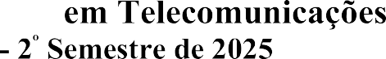



|  |  |  |  |  |  |  |  |
| --- | --- | --- | --- | --- | --- | --- | --- |
|  | | | | | | | |
|  | | | | |  | | |
|  | | | | | | | |
|  |  | | | | | | |
|  | | | | | | | |
|  | |  | | | | | |
|  | | | | | |  | |
|  | | | | | |  | |
|  | | | | | | | |
|  | | | | | | | |
|  | | | | | | | |
|  | | | |  | | |  |
|  | | | | | | | |
|  | | | | | | | |
|  | | |  | | | | |
|  | | | | | | | |
|  | | | | | | | |
|  | | | | | | | |
|  | | |  | | | | |
|  | | | | | | | |
|  | | | | | | | |

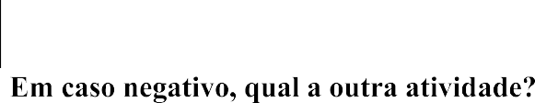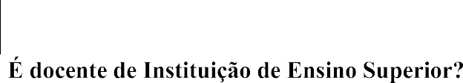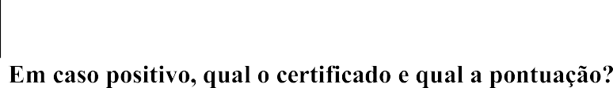

|  |
| --- |
|  |
|  |
|  |
|  |
|  |
|  |
|  |
|  |
|  |
|  |

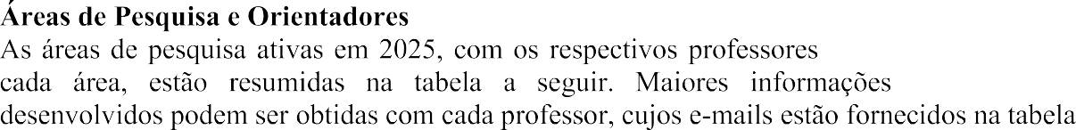



|  |  |  |  |  |  |  |  |  |  |  |  |  |  |
| --- | --- | --- | --- | --- | --- | --- | --- | --- | --- | --- | --- | --- | --- |
|  |  |  |  | **Fernando** Darío A. Garcia  fernando.garcia@posdoc.inatel.br | **Guilherme** Pedro Aquino  guilhermeaquino@inatel.br |  |  |  |  |  |  |  |  |
|  |  |  |  |  |  |  |  |  |  |  |  |  |  |
|  |  |  |  |  |  |  |  |  |  |  |  |  |  |
|  |  |  |  |  |  |  |  |  |  |  |  |  |  |
|  |  |  |  |  |  |  |  |  |  |  |  |  |  |
|  |  |  |  |  |  |  |  |  |  |  |  |  |  |
|  |  |  |  |  |  |  |  |  |  |  |  |  |  |
|  |  |  |  |  |  |  |  |  |  |  |  |  |  |
|  |  |  |  |  |  |  |  |  |  |  |  |  |  |
|  |  |  |  |  |  |  |  |  |  |  |  |  |  |
| Segurança Cibernética |  |  |  |  | X |  |  |  |  |  | X |  |  |
|  |  |  |  |  |  |  |  |  |  |  |  |  |  |
|  |  |  |  |  |  |  |  |  |  |  |  |  |  |
|  |  |  |  |  |  |  |  |  |  |  |  |  |  |













